|  |  |  |  |  |  |  |
| --- | --- | --- | --- | --- | --- | --- |
| ***Python Programming***    **LABORATORY MANUAL**  **B.Tech Semester -IV**  **Subject Code: (KNC-402)**      **Session: 2020-21, Even Semester**   |  |  | | --- | --- | | **Name:** | KUSHAGRA JAISWAL | | **Roll. No.:** | 2000910139004 | | **Group/Branch:** | I.T-1 |       **JSS MAHAVIDYAPEETHA**  **DEPARTMENT OF INFORMATION TECHNOLOGY**  **JSSACADEMY OF TECHNICAL EDUCATION**  **C-20/1, SECTOR-62, NOIDA** |

OBJECT-:

To write a python program to perform Matrix Multiplication. (Without builtin functions)

PROGRAM-:

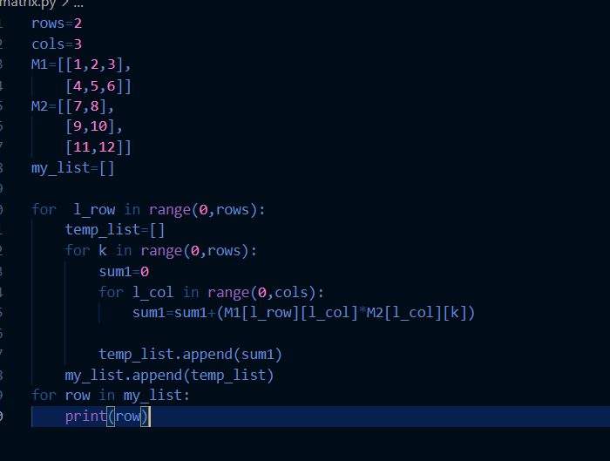

**OUTPUT-:**

